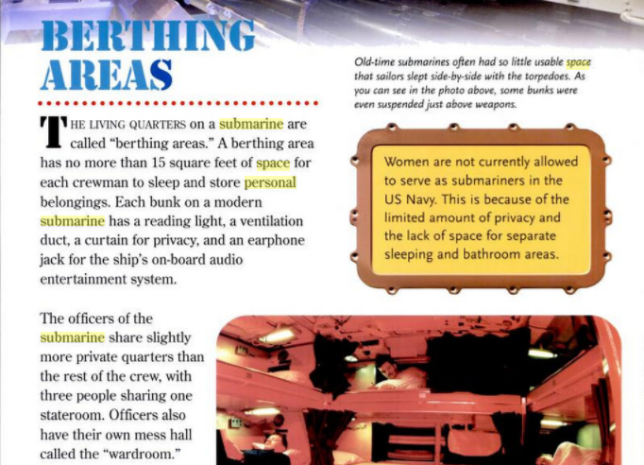

Submarines up Close – Andra Serlin Abramson 2008

Navy.com says deployment ranges from 3-6months

NASA**Study performed under NASA Contract No. NAS 2-11723 for NASA/Ames by the McDonnell Douglas Corp**

Space Station Functional Relationship Analysis (1988)

Talks about the space requirements and how to group different facilities (e.g. meal prep, dining area, conference area, hygiene facilities, personal area, etc) in a habitat. Discusses how some can be combined and others need to be separate.

Yvonne A. Clearwater, Space station habitability research, Acta Astronautica, Volume 17, Issue 2, 1988,

Talks about a program to simulate a habitat back in the 80’s, one key thing they mentioned though was, “The measurement of sheer physical space in any terms of “habitable volume’ (e.g. free volume or floor space) is insufficient to characterize the behavioral, psychological and social consequences (or the human experience in space).”

**Space Station Habitability Recommendations Based on a Systematic Comparative Analysis of Analogous Conditions – Jack Stuster, 1986 https://ntrs.nasa.gov/search.jsp?R=19880015988**

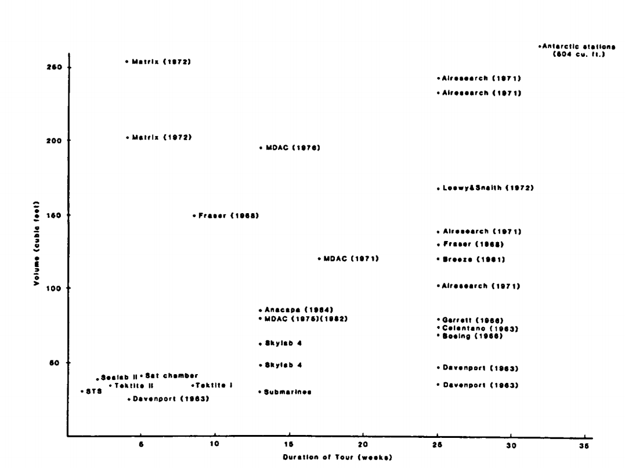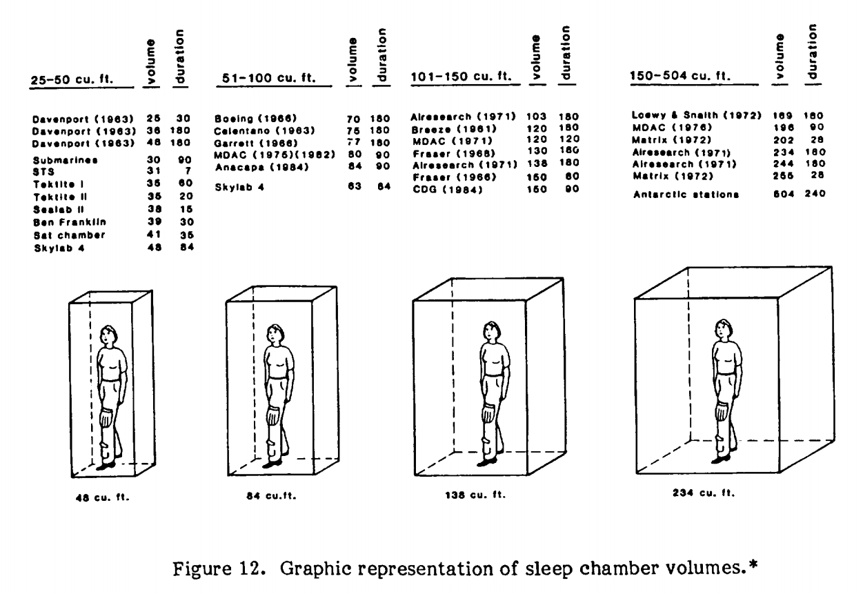

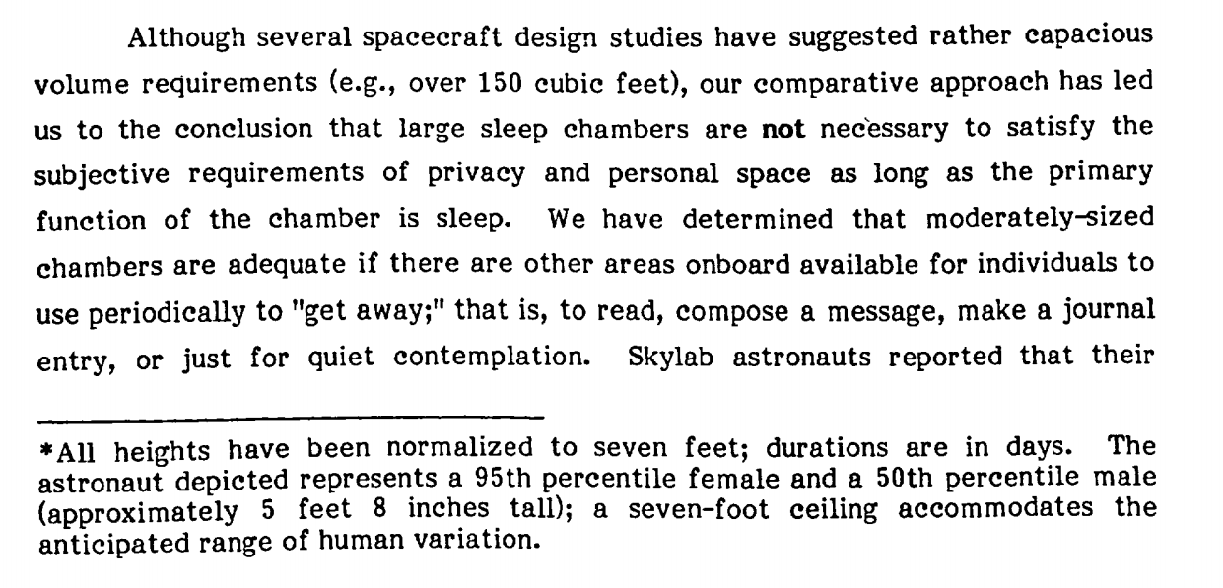

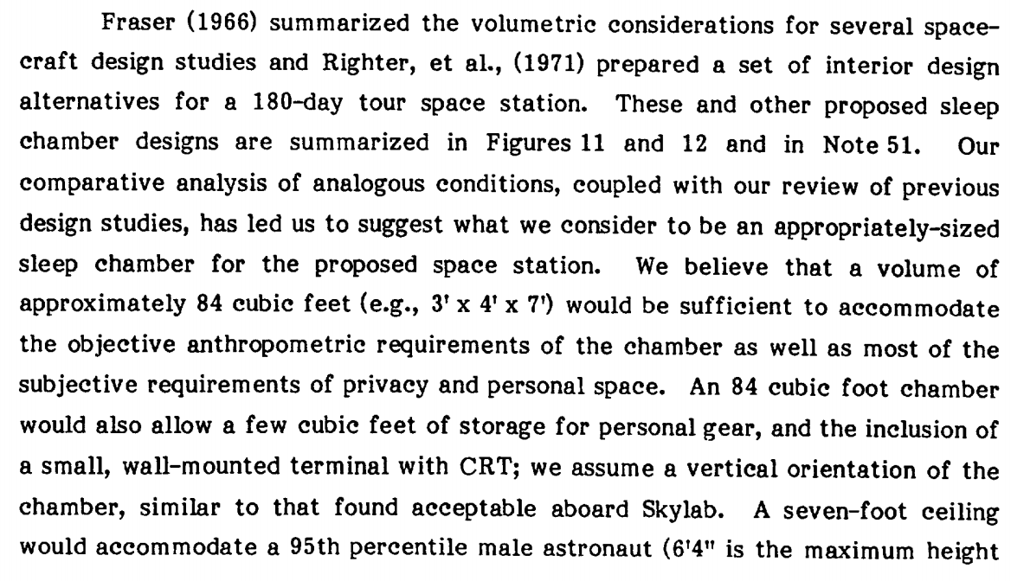

**Human Needs: Sustaining Life During Exploration – Nasa.gov**

When astronauts travel into space, NASA scientists determine how much food will be needed for each mission. For example, an astronaut on the ISS uses about 1.83 pounds (0.83 kilograms) of food per meal each day. About 0.27 pounds (0.12 kilograms) of this weight is packaging material. Longer-duration missions will require much more food.

A trip to Mars and back, for instance, may take more than three years and require the provision of thousands of kilograms of food. A crew of four on a three-year martian mission eating only three meals each day would need to carry more than 24,000 pounds (10,886 kilograms) of food.

**Food for Space Flight Space Food History – Nasa.gov**

The kinds of foods the Space Shuttle astronauts eat are not mysterious concoctions, but foods prepared here on Earth, many commercially available on grocery store shelves. Diets are designed to supply each Shuttle crew member with all the Recommended Dietary Allowances (RDA) of vitamins and minerals necessary to perform in the environment of space. Caloric requirements are determined by the National Research Council formula for basal energy expenditure (BEE). For women, BEE = 655 + (9.6 x W) + (1.7 x H) - (4.7 x A), and for men, BEE = 66 + (13.7 x W) + (5 x H) - (6.8 x A), where W = weight in kilograms, H = height in centimeters, and A = age in years.

**F.B. Salisbury, W.F. Campbell, J.G. Carman, G.E. Bingham “Plant growth during the greenhouse II experiment on the Mir orbital station,” Advances in Space Research, Volume 31, Issue 1, 2003,**

Super Dwarf wheat was harvested after 90 days.